

**Activate SharePoint Online Migration**

**Scenario Guide 4.2**

Migrate SharePoint Server content to SharePoint Online then connect to Microsoft Teams



**Conditions and Terms of Use**

**Microsoft Confidential**

This training package is proprietary and confidential, and is intended only for uses described in the training materials. Content and software is provided to you under a Non-Disclosure Agreement and cannot be distributed. Copying or disclosing all or any portion of the content and/or software included in such packages is strictly prohibited.

The contents of this package are for informational and training purposes only and are provided "as is" without warranty of any kind, whether express or implied, including but not limited to the implied warranties of merchantability, fitness for a particular purpose, and non-infringement.

Training package content, including URLs and other Internet Web site references, is subject to change without notice. Because Microsoft must respond to changing market conditions, the content should not be interpreted to be a commitment on the part of Microsoft, and Microsoft cannot guarantee the accuracy of any information presented after the date of publication. Unless otherwise noted, the companies, organizations, products, domain names, e-mail addresses, logos, people, places, and events depicted herein are fictitious, and no association with any real company, organization, product, domain name, e-mail address, logo, person, place, or event is intended or should be inferred.

**Copyright and Trademarks**

© 2020 Microsoft Corporation. All rights reserved.

Microsoft may have patents, patent applications, trademarks, copyrights, or other intellectual property rights covering subject matter in this document. Except as expressly provided in written license agreement from Microsoft, the furnishing of this document does not give you any license to these patents, trademarks, copyrights, or other intellectual property.

Complying with all applicable copyright laws is the responsibility of the user. Without limiting the rights under copyright, no part of this document may be reproduced, stored in or introduced into a retrieval system, or transmitted in any form or by any means (electronic, mechanical, photocopying, recording, or otherwise), or for any purpose, without the express written permission of Microsoft Corporation.

For more information, see Use of Microsoft Copyrighted Content at

<http://www.microsoft.com/en-us/legal/intellectualproperty/Permissions/default.aspx>

DirectX, Hyper-V, Internet Explorer, Microsoft, Outlook, OneDrive, SQL Server, Windows, Microsoft Azure, Windows PowerShell, Windows Server, Windows Vista, and Zune are either registered trademarks or trademarks of Microsoft Corporation in the United States and/or other countries. Other Microsoft products mentioned herein may be either registered trademarks or trademarks of Microsoft Corporation in the United States and/or other countries. All other trademarks are property of their respective owners.

Contents

4.2 Migrate SharePoint Server content to SharePoint Online then connect to Microsoft Teams 5

**Objective** 5

**Scenario** 5

**Getting started** 5

How Microsoft Teams handles file storage 5

How to surface migrated content in Microsoft Teams 6

Option 1: Migrate content to SharePoint Online first 6

Option 2: Create a team first then migrate content 6

Prerequisites 7

**Start scenario** 7

4.2.1 Create a new team 7

Option 1: Create a Team using PowerShell 7

Option 2: Create a new Team using the Teams App 8

4.2.2 Locate URL of the connected SharePoint Online site 10

Option 1: Use PowerShell to find the URL 10

Option 2: Use the Teams App to find the URL 11

4.2.3 Migrate content to the connected SharePoint Online site 13

4.2.4 Surface the migrated content in Teams using Tabs, Cloud Storage or Move feature 20

Surface content by adding a Tab 21

Surface content using the Add Cloud Storage feature 24

Surface content using the Move feature in SharePoint Online 27

4.2.5 Create a new team from a SharePoint Online site 30

Connect the modern SharePoint Online to a Microsoft 365 Group 30

Create a Team from the new Microsoft 365 Group connected SharePoint site 33

Surface the content in Teams 34



## Migrate SharePoint Server content to SharePoint Online then connect to Microsoft Teams

## **Objective**

Microsoft Teams is a real-time collaboration and communication tool that is part of the Microsoft 365 suite of services. In this scenario you will learn how to migrate content from SharePoint Server to SharePoint Online and how to connect that migrated content to a Microsoft Team. Understand the various options and considerations when migrating to Microsoft Teams and how it fits into the overall migration strategy.

## **Scenario**

You want to migrate a site in SharePoint Server to Microsoft 365. You also want to change the collaboration experience from classic SharePoint sites to the modern experience powered by Microsoft Teams.

* Learn how file storage works in Microsoft Teams.
* Learn about the migration approaches for Microsoft Teams.
* Identify a site in SharePoint Sever to migrate to Microsoft 365.
* Create a new team in Microsoft Teams.
* Choose (or create) a SharePoint Online site to act as the migration target.
* Migrate the SharePoint Server site to the target SharePoint Online site using the SharePoint Migration Tool.
* Surface content from the migrated site in the team using various approaches.

## **Getting started**

Before starting the migration scenario, learn how Microsoft Teams handles file storage, and understand the overall migration strategy for Microsoft Teams.

### How Microsoft Teams handles file storage

Each team in Microsoft Teams has a team site in SharePoint Online, and each channel in a team gets a folder within the default team site document library. Files shared within a conversation are automatically added to the document library, and permissions and file security options set in SharePoint are automatically reflected within Teams.

The following graphic is the example of the relationships between team, channel, and document library:

Box on left Teams. Team 1 parent and sub channels
Box on right SharePoint Online with Shared Document library and Folders for each corresponding Channel

Source: How SharePoint Online and OneDrive for Business interact with Microsoft Teams: <https://docs.microsoft.com/en-us/MicrosoftTeams/sharepoint-onedrive-interact>

To learn how Teams interacts with Azure Active Directory (AAD), Microsoft 365 Groups, Exchange, SharePoint and OneDrive for Business: **Foundations of Microsoft Teams**: <https://aka.ms/teams-foundations>

### How to surface migrated content in Microsoft Teams

Migration to Teams starts by migrating content to a SharePoint Online site, then surfacing that content in a target team. First, choose a SharePoint Online site to act as the migration target. Once the content is in a SharePoint Online site it can be surfaced in a team using a variety of options.

#### Option 1: Migrate content to SharePoint Online first

1. Use the **SharePoint** **Migration** **Tool** to migrate content to a new SharePoint Online site.
2. From the SharePoint Online site click **Connect to new Microsoft 365 Group**.
3. From the SharePoint Online site click **Create a Team**.
4. Surface content in the team using **Tabs**, **Cloud** **Storage** or the SharePoint **move** feature.
5. Encourage users to use the **Microsoft** **Teams** interface to collaborate and access the content.

#### Option 2: Create a team first then migrate content

1. Create a team (or use an existing team)
2. Use the **SharePoint** **Migration** **Tool** to migrate content into the SharePoint Online site connected to the team. Surface content in the team using **Tabs**, **Cloud** **Storage** or the SharePoint **move** feature.

**Note**: Alternatively, you can migrate document libraries(s) from the source SharePoint Server site directly into the “General” folder connected to the Team using CSV/Json file. *Migration of content into a target folder is not available in the SPMT GUI as of Version 3.2.114.0.*

1. Encourage users to use the **Microsoft** **Teams** interface to collaborate and access the content.

The migration options listed above create a 1:1 relationship between a team in Microsoft Teams to a SharePoint Online site containing the migrated content. However, it is important to understand that content can be surfaced in a team from multiple SharePoint Online sites regardless if they exist in classic or modern sites.

### Prerequisites

Identify a SharePoint Server site to migrate to Microsoft 365 (or create a new site). The SharePoint Server site should meet the following requirements:

* The site must have at least **3 document libraries** each containing some content.
* The total size of the SharePoint Server site should be less than **2GB** - so that the migration can complete quickly.
* Record the **Title** and **URL** of the site.

## **Start scenario**

Follow the instructions below to complete the scenario:

### Create a new team

Create a new team that will be used to surface the migrated content. The team can be created using **PowerShell** or the **Teams** **App**.

#### Option 1: Create a Team using PowerShell

From your client machine install the **MicrosoftTeams** **PowerShell** module and run the **New**-**Team** PowerShell cmdlet.

1. Open **PowerShell as Administrator** and run **Install-Module MicrosoftTeams**
2. Run **Connect-MicrosoftTeams**
3. In the Credential prompt, enter credentials of account with **Global Administrator** or **Team Service Administrator** roles to the target Microsoft 365 tenant:

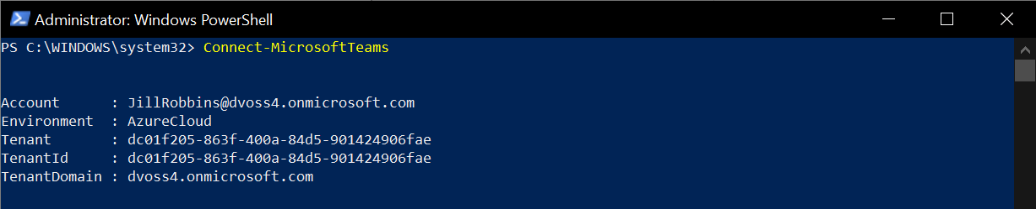

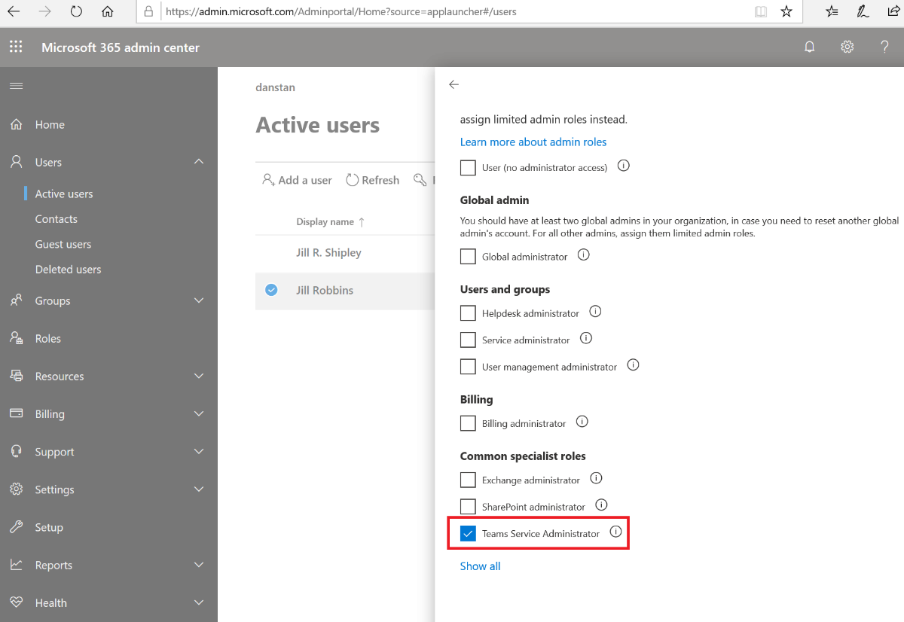

1. Run **New-Team** cmdlet to create a new Team:

New-Team -DisplayName "<Enter Name>" -Description "<Enter Description>" -Visibility <Public, Private, HiddenMembership> -Owner "<Enter email>"

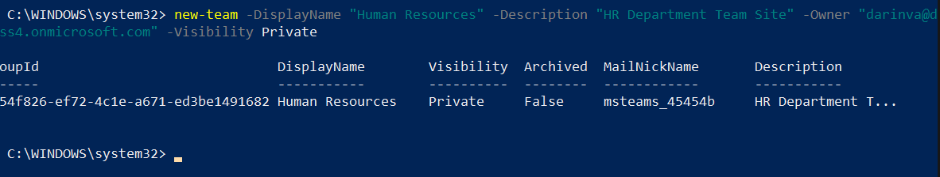

#### Option 2: Create a new Team using the Teams App

Create a new Team using the Teams App:

1. Open the browser and navigate to <https://teams.microsoft.com>
2. When prompted to authenticate entre the credentials of an account with **Global Administrator** or **Team Service Administrator** roles to the target Microsoft 365 tenant.
3. At the bottom of the Teams App click on **Join or Create a Team**
4. Click on **Create a Team** and select **Build a Team from Scratch**.
5. Choose the visibility mode: **Private**

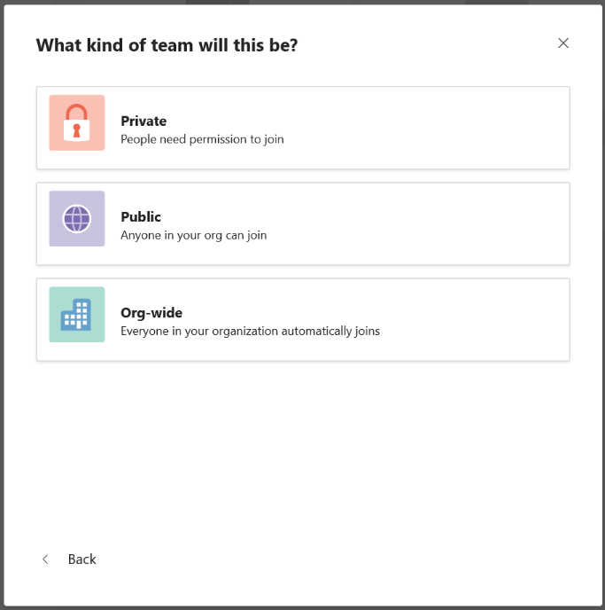

1. On the **Team name** prompt enter a **Team name**, add a Description, and click **Create**.

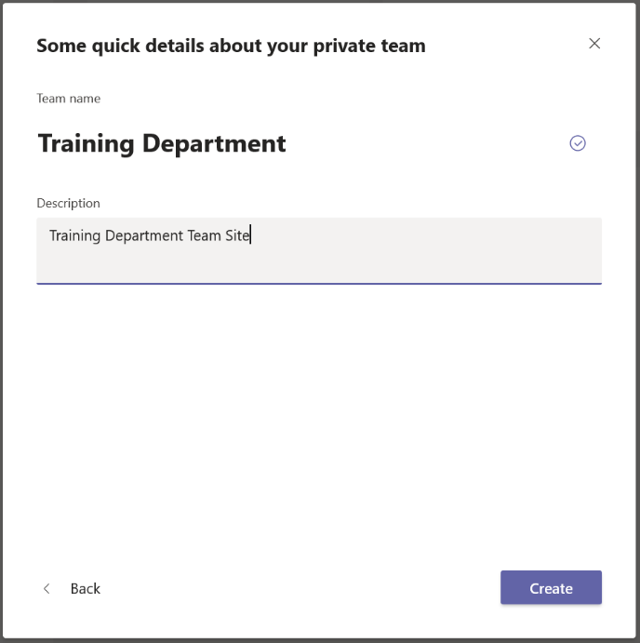

1. On the **Add members to** <Team Name> prompt enter the group or names of users who should have permissions to the site and click **Add**. Click **close** when completed.

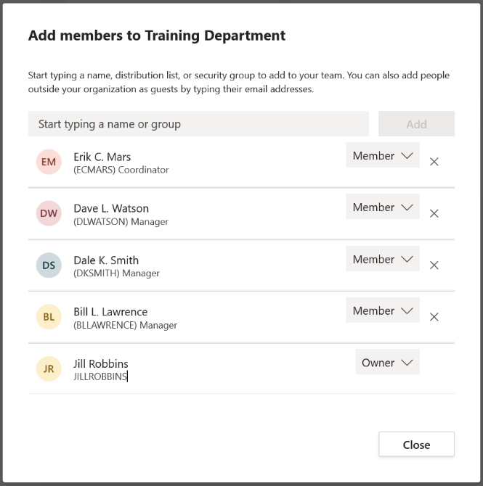

### Locate URL of the connected SharePoint Online site

Creating a new team automatically creates a connected SharePoint Online site to host files shared in the channels. The connected SharePoint Online site is created with a **Title** matching the team’s **Display** **Name**. The **URL** of the connected SharePoint Online site will resemble the team’s **Display** **Name**, but with any special characters, spaces, and excessive length being removed to create a more URL-friendly syntax/format. Given the team’s Display Name might not match the URL of the connected SharePoint Online site, it is recommended to confirm the exact URL before attempting a migration.

There are two ways to identify the URL of the connect SharePoint Online site: use **PowerShell** or use the **Teams** **App**.

#### Option 1: Use PowerShell to find the URL

From your client machine install the **SharePoint** **Online** **PowerShell** **module** and run the **Get**-**SPOSite** PowerShell cmdlet.

1. Download the latest **SharePoint** **Online** **Management** **Shell**: <https://go.microsoft.com/fwlink/p/?LinkId=255251>

**Note**: If you installed a previous version of the SharePoint Online Management Shell, go to Add or remove programs and uninstall “SharePoint Online Management Shell.” On the Download Center page, select your language and then click the Download button. You’ll be asked to choose between downloading a x64 and x86 .msi file. Download the x64 file if you’re running the 64-bit version of Windows or the x86 file if you’re running the 32-bit version. If you don’t know, see <https://support.microsoft.com/help/13443/windows-which-operating-system>. After the file downloads, run it and follow the steps in the Setup Wizard.

1. Open **PowerShell as Administrator** andrun **Connect-SPOService** cmdlet**:**

Connect-SPOService -Url https://<tenantname>-admin.sharepoint.com

1. In the Credential prompt, enter credentials of account with **Global Administrator** or **SharePoint Administrator** roles to the Microsoft 365 tenant:

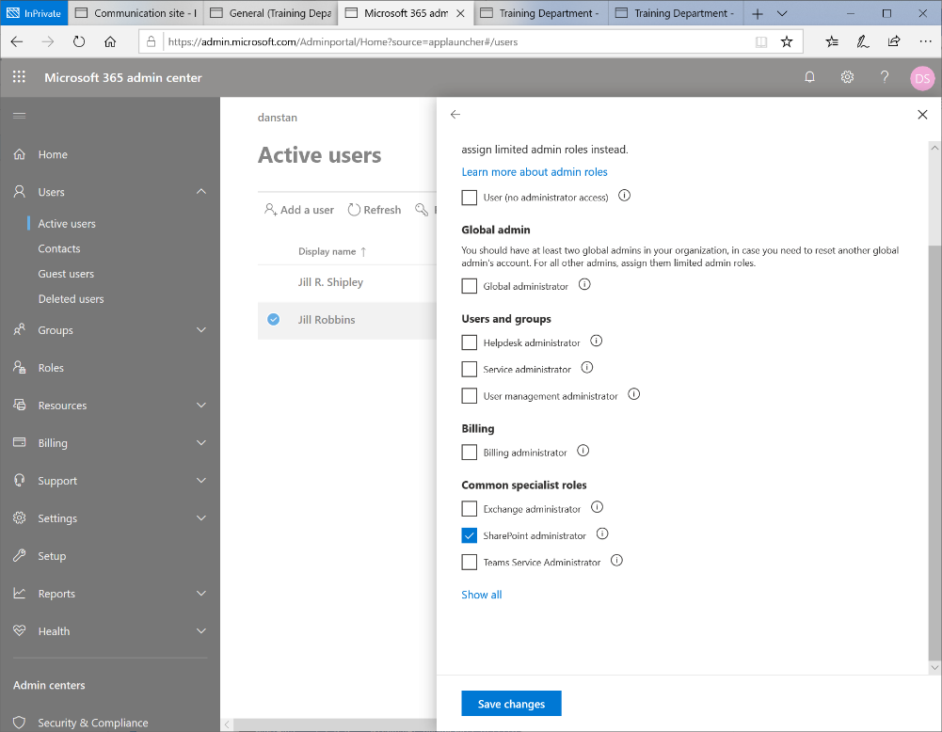

1. Run the **Get-SPOSite** cmdlet and replace “Training Department” with the **Display** **Name** of the team you created in the previous steps:

$Site = Get-SPOSite -Limit All | Where-Object {$_.Title -eq "Training Department"}

$Site.Url

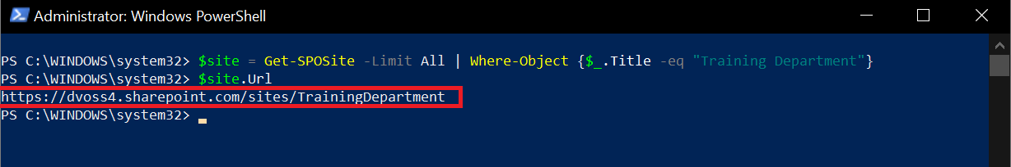

1. Copy the **URL** of the SharePoint Online site in the PowerShell window. (for example: [https://dvoss4.sharepoint.com/sites/TrainingDepartment](https://dvoss4.sharepoint.com/sites/TrainingDepartment/Shared%20Documents/Forms/AllItems.aspx?viewid=beac4a3b%2D5eb2%2D4d2c%2Dbceb%2Daf61975af800&id=%2Fsites%2FTrainingDepartment%2FShared%20Documents%2FGeneral))

#### Option 2: Use the Teams App to find the URL

Use the Teams App to find the URL to the connected SharePoint Online site:

1. Open the Teams App and click on **Teams** in the navigation window.
2. If you do not see the team in the list, click on the **Filter** icon and enter the name of the new team you created in the previous steps and search for it.
3. Click on the name of the team as it appears in the panel.
4. In the **General** **Channel** of the team, click on the **Files** tab. Click on **Open in SharePoint**.

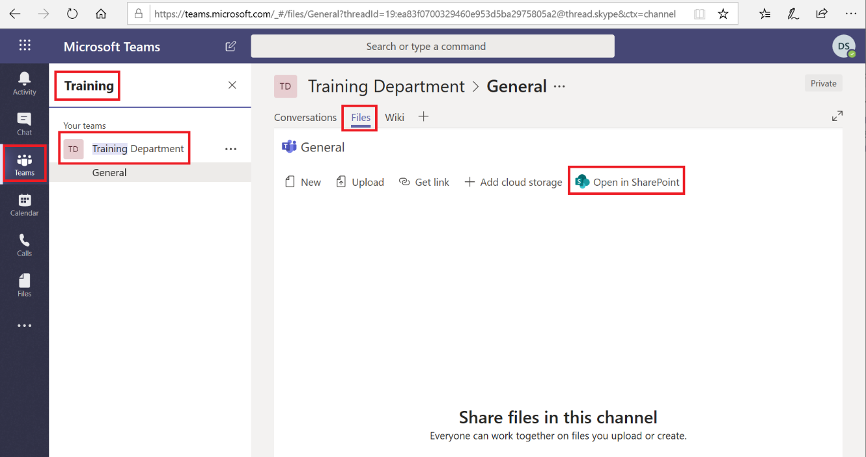

1. The **Open** **in** **SharePoint** link will open the site in the browser and specifically to the “General” folder in the **Shared** **Documents** Library of the site:

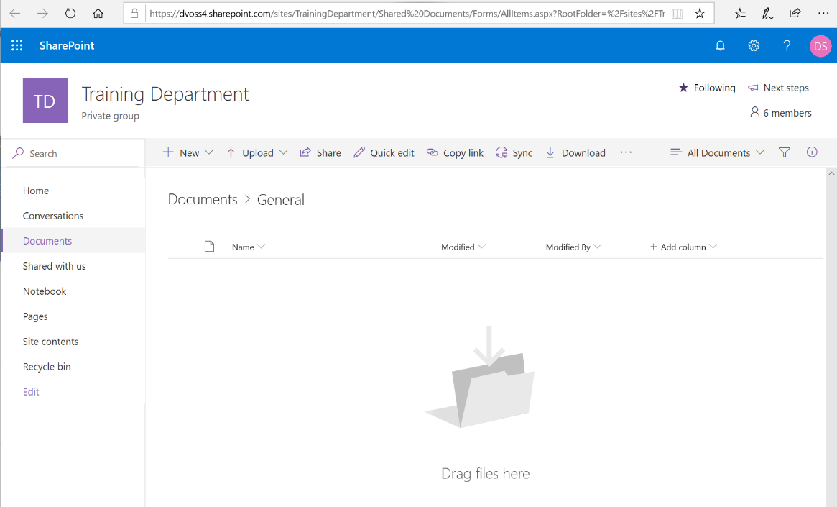

1. Copy the **URL** to the SharePoint Online site, for example: [https://<tenantname>.sharepoint.com/sites/TrainingDepartment](https://dvoss4.sharepoint.com/sites/TrainingDepartment/Shared%20Documents/Forms/AllItems.aspx?viewid=beac4a3b%2D5eb2%2D4d2c%2Dbceb%2Daf61975af800&id=%2Fsites%2FTrainingDepartment%2FShared%20Documents%2FGeneral)

### Migrate content to the connected SharePoint Online site

Use the **SharePoint** **Migration** **tool** to migrate content from the SharePoint Server site to the connected SharePoint Online site.

1. Launch the **SharePoint Migration Tool**
2. On the **Sign in to your account** prompt, enter credentials of an account with **Global Administrator** or **SharePoint** **Administrator** roles to the target M365 tenant
3. If you see a **Welcome** **to** **the** **SharePoint** **Migration** **Tool** screen click **Start** **your** **first** **migration**

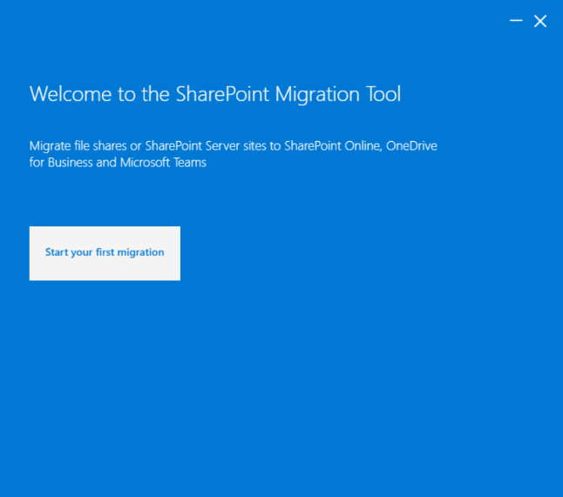

If you see a **Welcome back to the SharePoint Migration Tool** screen click **Start new migration.**

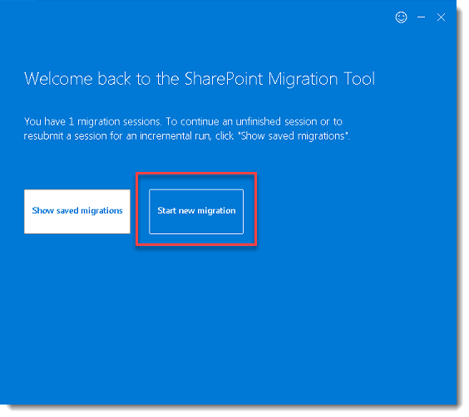

1. On the **Where’s your content** screen select **SharePoint Server**

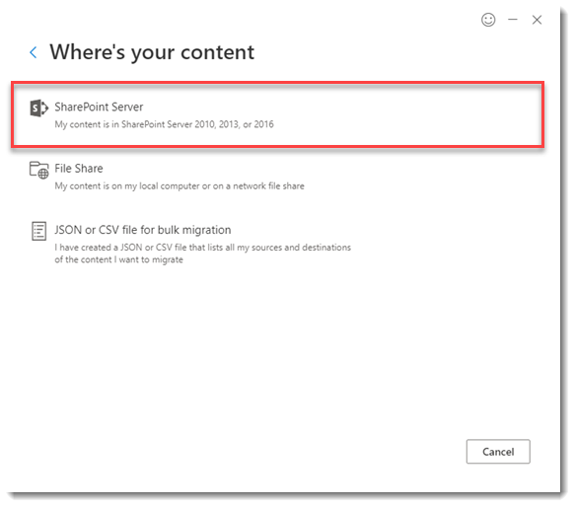

1. On the **Select a source** screen, enter the URL of the source site in the **What site contains the content** area and click outside the box to invoke the sign-in process.
2. On the **Sign-in to the site** **below** **to** **authenticate** prompt, enter the credentials of an account with **Site** **Collection** **Administrator** permissions to the site collection, then click **Sign in**.
3. Returning to the **Select** **a** **source** **screen**, check the box **Include** **all** **subsites** (if there are sub-sites), and in the **Select** **the** **content** **you** **wish** **to** **migrate** screen, select **Migrate** **all** **lists**, **libraries**, **pages** **and** **web** **parts** from the dropdown, then click **Next** to proceed.

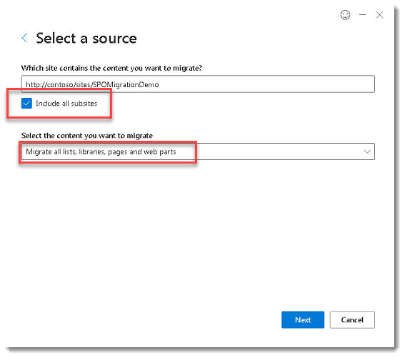

If prompted in the **Sign-in to the site below to authenticate** enter credentials of an account thathas access to the source SharePoint Server site.

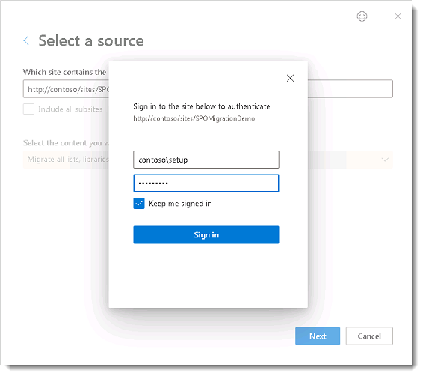

1. On the **Where do you want to move it to** screen select **SharePoint team Site.**

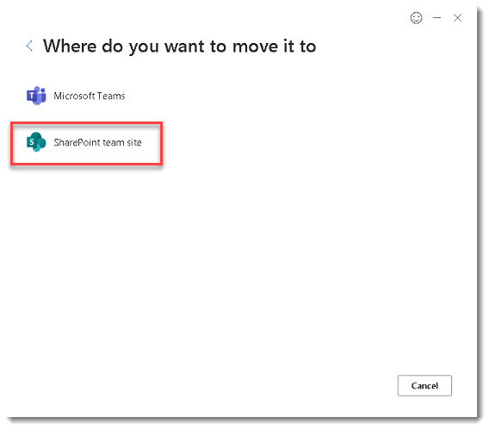

1. On the **Select** **a** **destination** screen enter the URL to the target SharePoint Online site that you obtained in the previous steps. Confirm you see the informational text: “**Your** **content** **will** **be** **moved** **to** **this** **site**.” Click **Next** to proceed.

You may get a warning about scripts being disabled you can click **OK.**

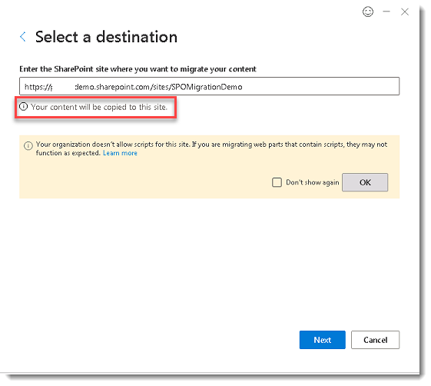

1. On the **Review** **migration** screen, in the **Name** **your** **migration** field enter a unique name for the migration (or leave the default name) and click **Next**.

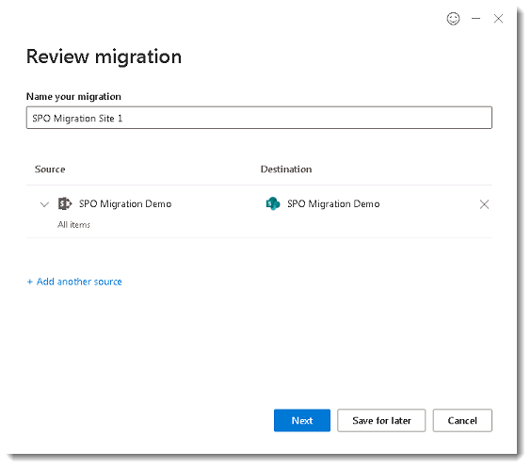

1. On the **choose** **your** **settings** screen leave all defaults and click **Migrate**

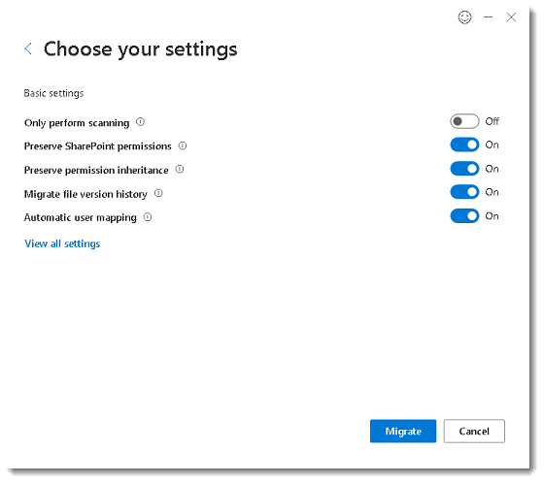

1. Monitor the migration progress.

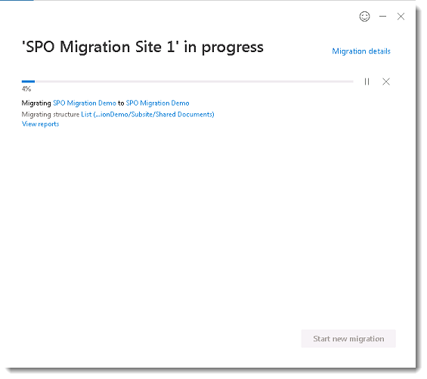

1. When the migration has completed click **Save**. Saving the site in the SharePoint Migration Tool allows you to perform an **incremental** migration to this same site later.

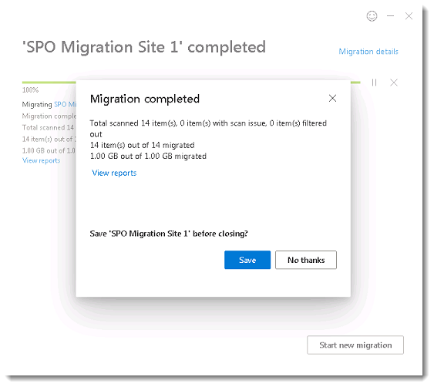

1. Open a browser and navigate to both the target SharePoint Online site, and the source SharePoint server site, and compare the **Site** **Contents** page from each site. The **Site** **Contents** page shows the libraries, lists, and subsites in the site. It may be easier to view the target SharePoint Online site in **classic** **experience**.

* **Source Site: SharePoint 2013 Team Site “/sites/training”**

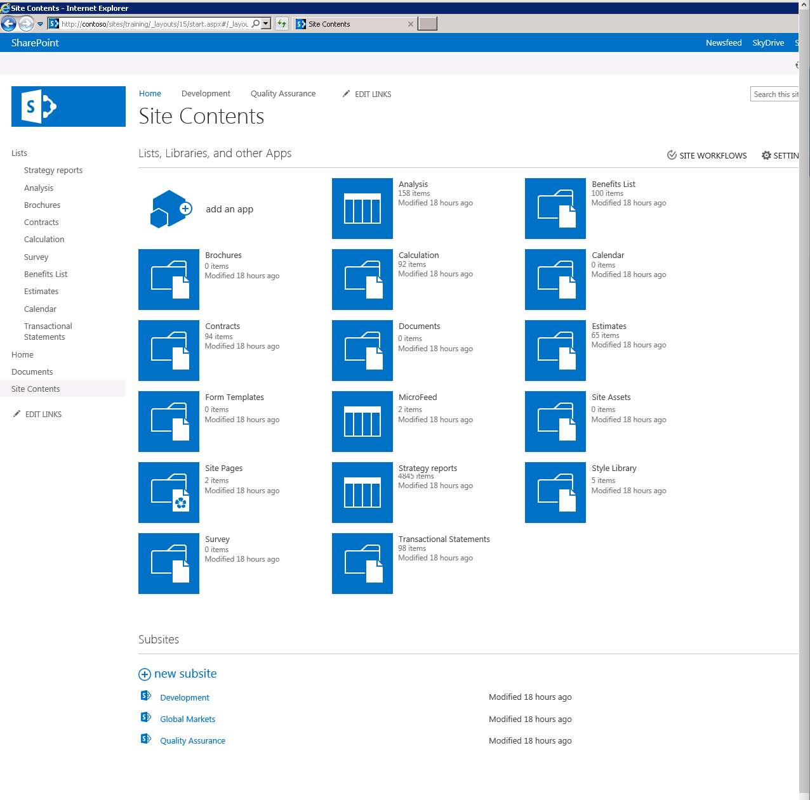

* **Target Site: SharePoint Online Site “/sites/trainingdepartment”** (Site Contents displayed in “classic experience” to demonstrate likeness.)

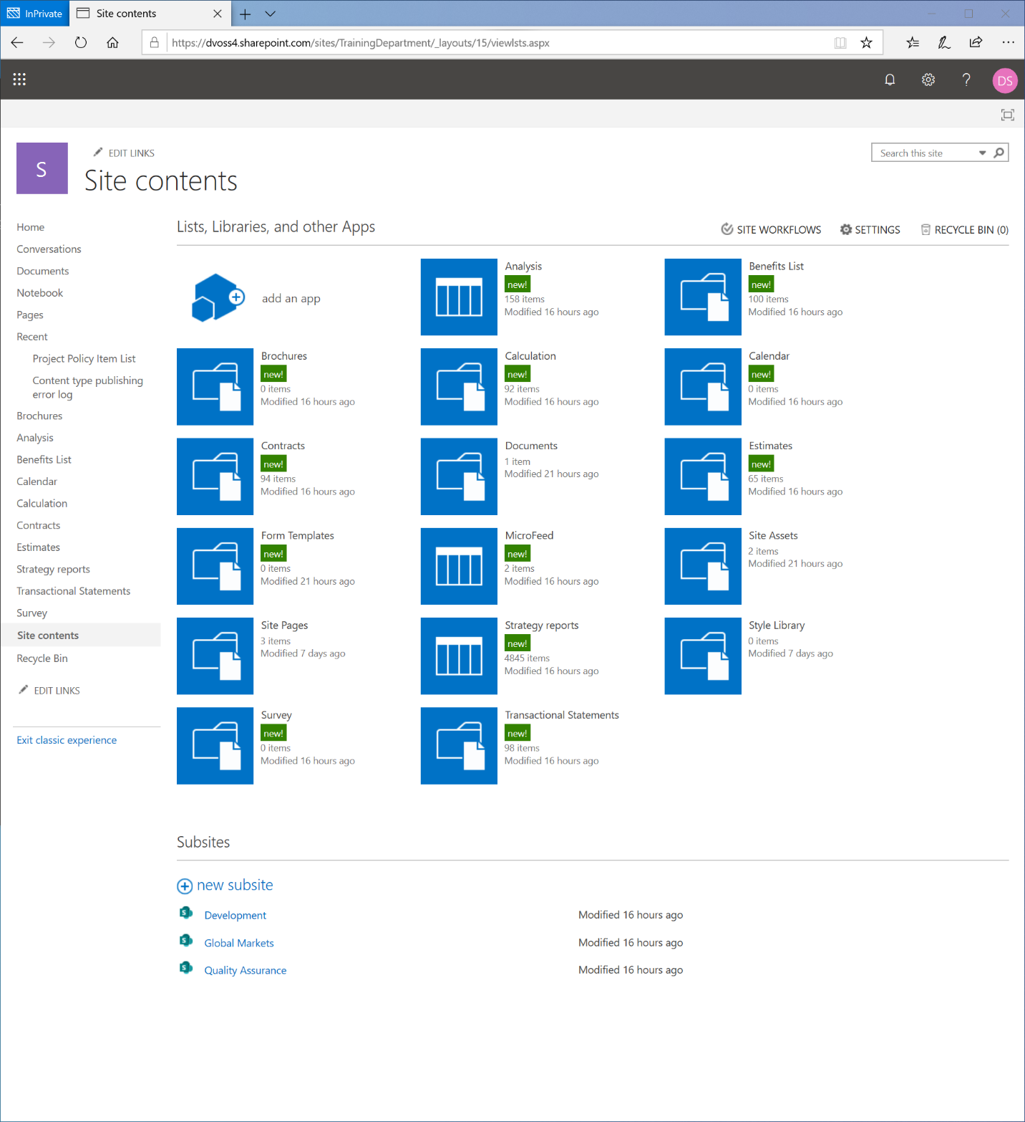

### Surface the migrated content in Teams using Tabs, Cloud Storage or Move feature

Now that the content is migrated to the connected SharePoint Online site the next step is to surface the content in Teams.

#### Surface content by adding a Tab

The add Tab feature in Teams creates a new Tab in the channel of the team that connects to a document library in a SharePoint Online site. The SharePoint Online site could be any site in the Microsoft 365 tenant that the user has permissions to, including ‘Classic” sites, or “Modern” team sites.

1. From the Teams App open the team and click on **+** symbol to add a **Tab**.
2. In the **Add** **a** **Tab** prompt, click on **Document** **Library**, and enter the URL to the target Document Library:

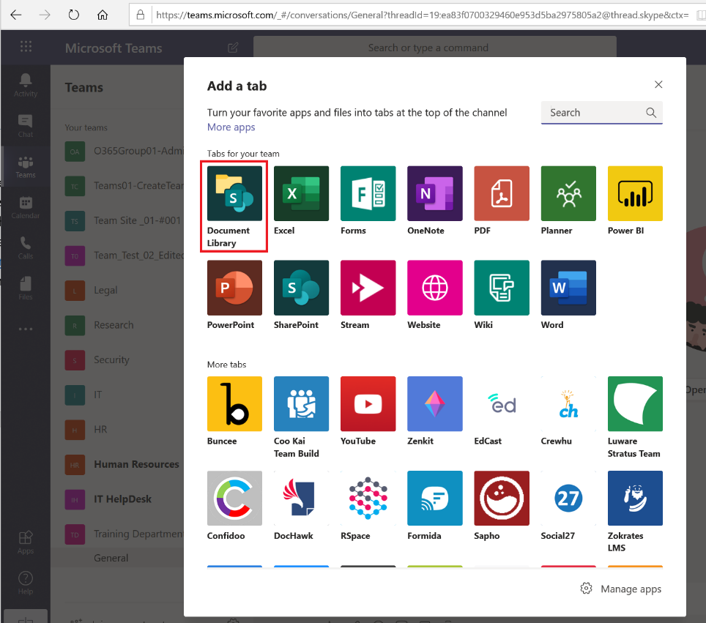

1. In the **Document** **Library** prompt, click use a **SharePoint** **link.** In the URL field enter the URL to the target SharePoint Online site then click **Go**. (for example: <https://dvoss4.sharepoint.com/sites/TrainingDepartment/>)

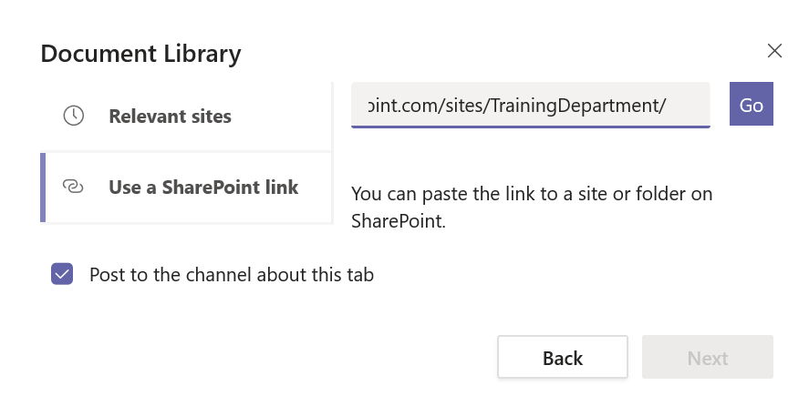

1. On the second **Document** **Library** screen, the title of the SharePoint site will be displayed, if it is correct, click **Next**.

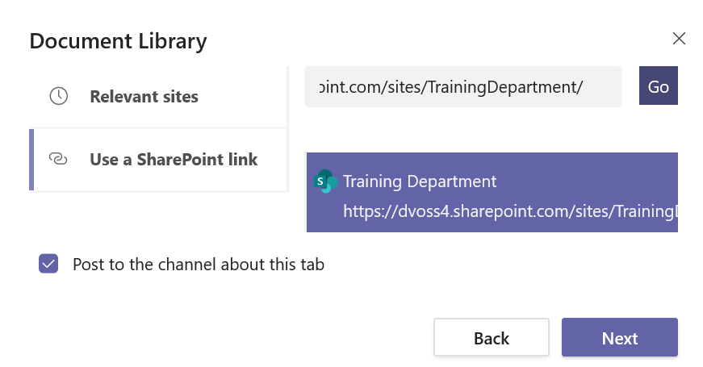

1. On the **Pick** **a** **Document** library screen select the document library you want to add as a tab to the target team and click **Next**.

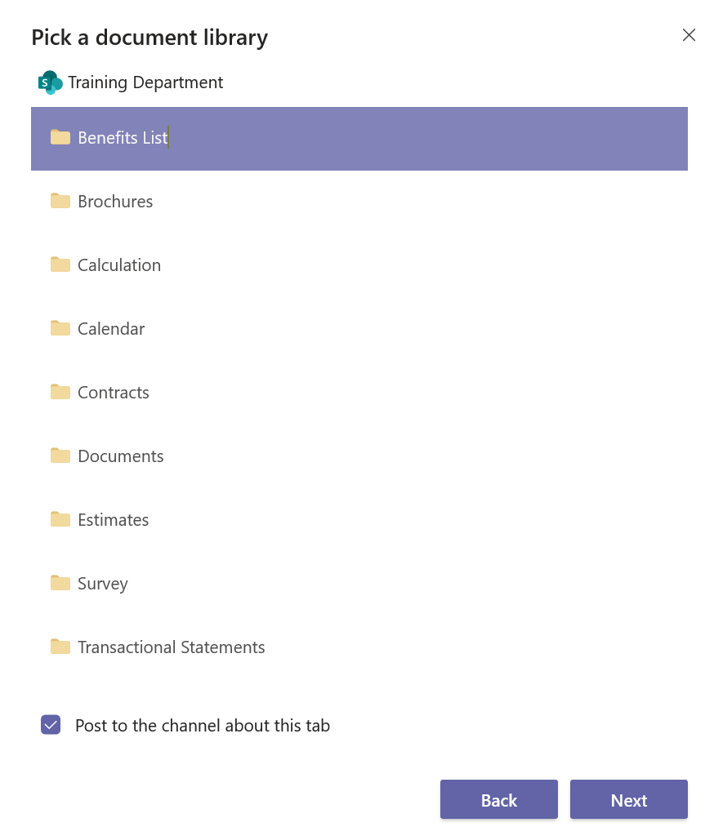

1. From the **Name** **your** **tab** screen, enter a name (or leave default name) and click **Save**.

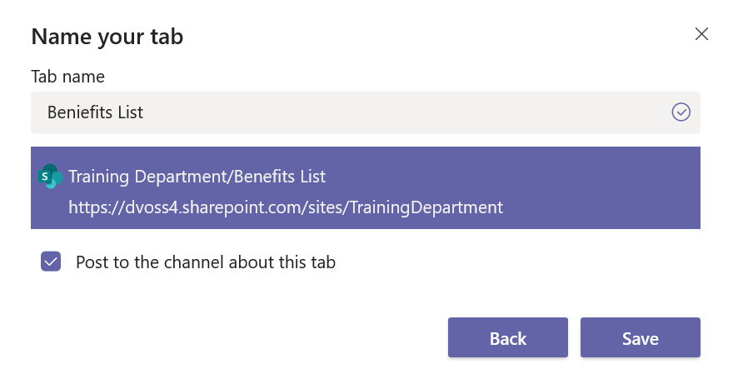

1. Confirm the **Tab** appears in the team along with the content:

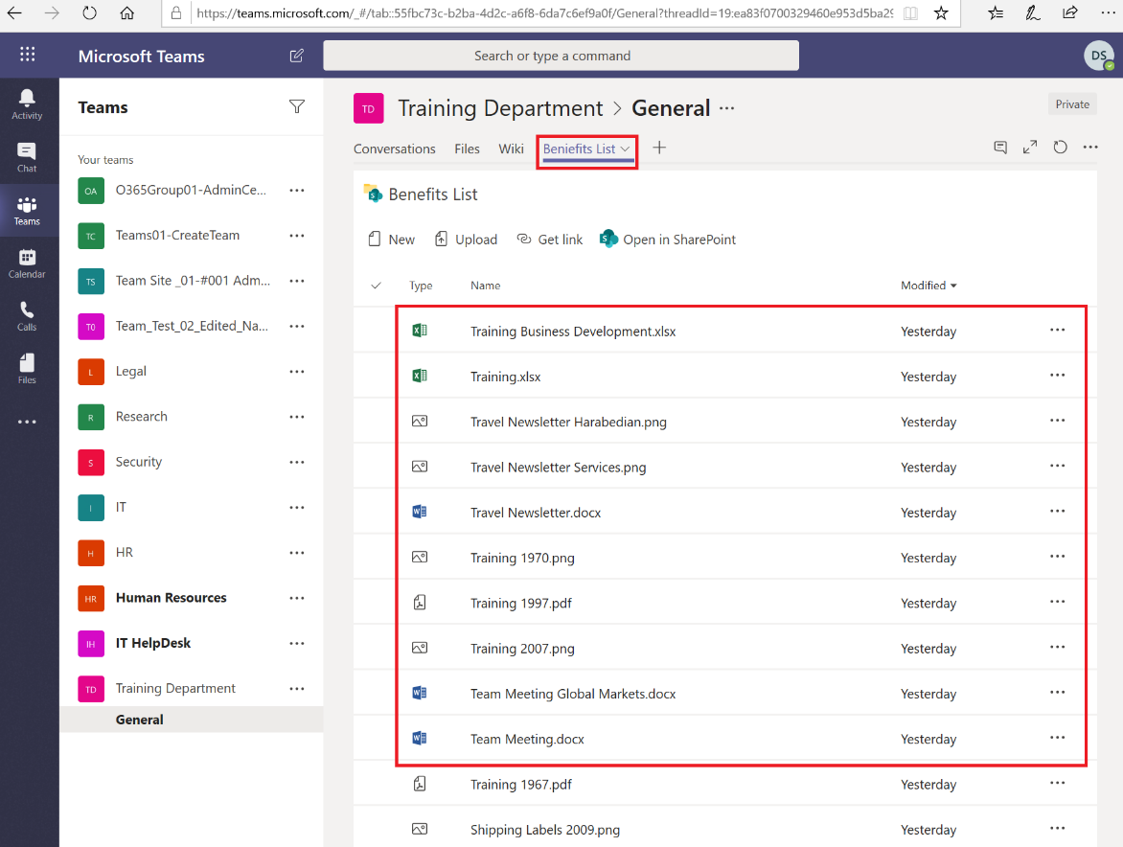

#### Surface content using the Add Cloud Storage feature

The add cloud storage feature in Teams connects a document library in a SharePoint Online site to the default Files tab of a channel in the team.

1. From Teams App, click on the target Team, then click the **Files** tab. Click on **+ Add cloud storage.**
2. In the **Add** **cloud** **storage** prompt, click on **SharePoint**.

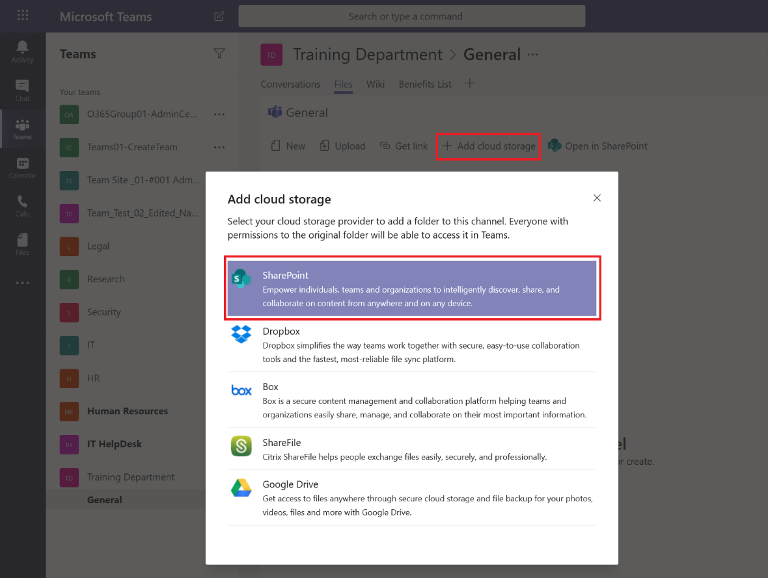

1. In the **Document** **Library** screen, click **Use** **a** **SharePoint** **Link** and enter the URL. Click **Go**. Confirm the title of the site is correct then click **Next**.

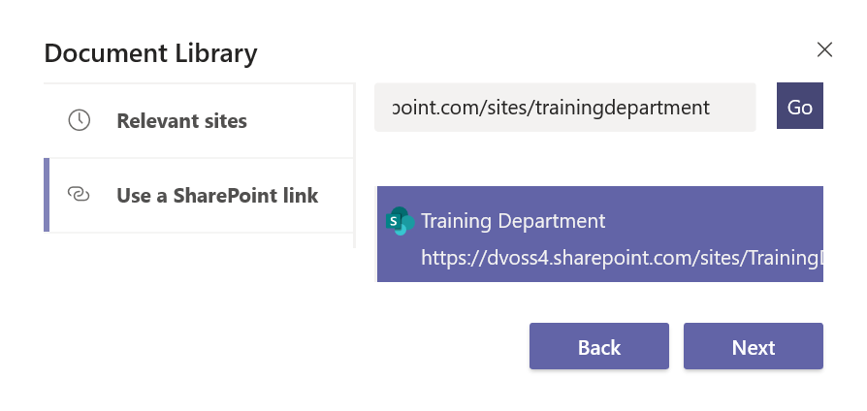

1. In the **Document** **Library** screen select the Document Library then click **Next**.

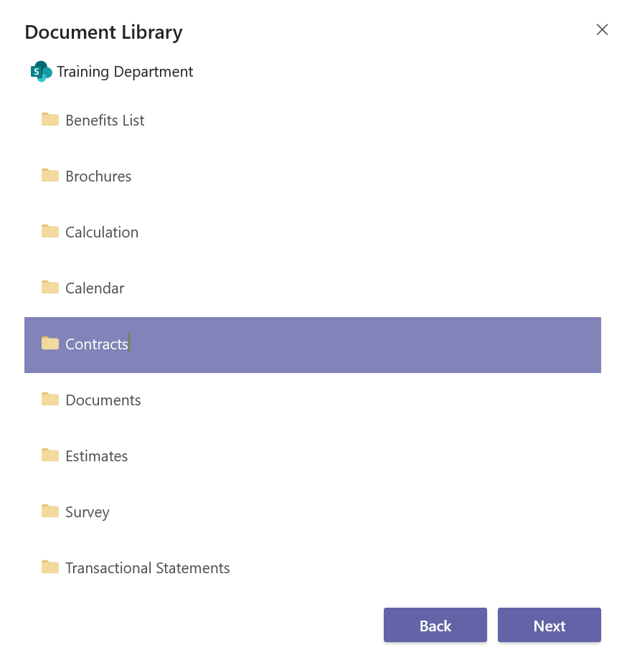

1. In the second **Document** **Library** screen click **Add** **folder**.

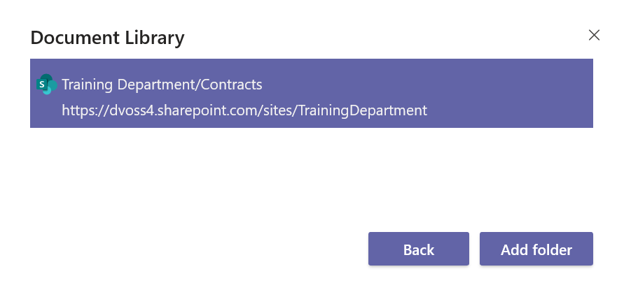

1. Confirm the Library is now visible in the target team. Navigate to the Team and click on **Files**. Look for the name of the library you added in the previous step.

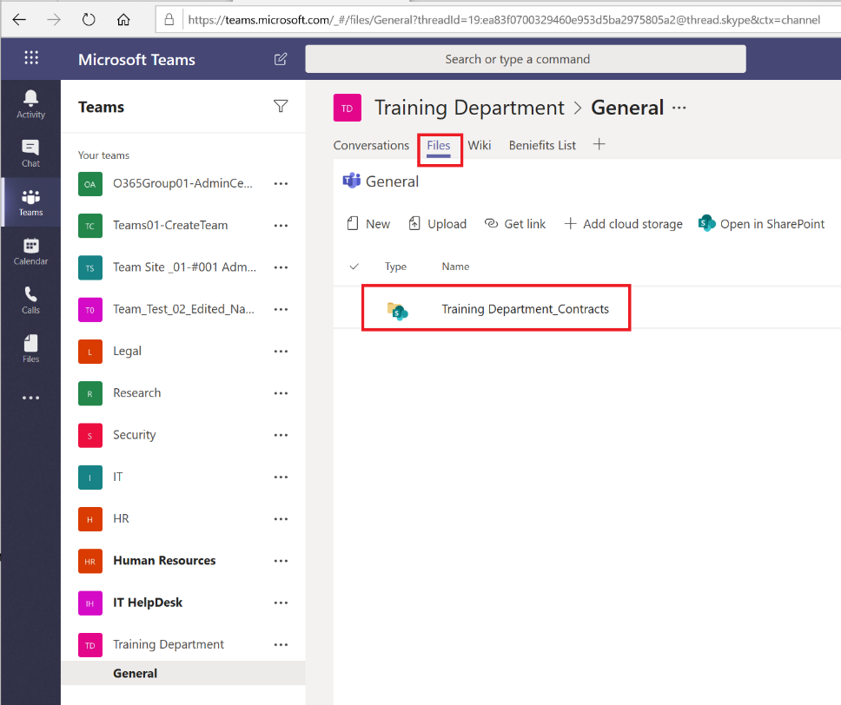

#### Surface content using the Move feature in SharePoint Online

Use the SharePoint Movefeature to move content from a Document Library to the “General” folder in the Shared Documents Library on the target SharePoint Online site.

1. Navigate to the target document library and select the **files** and/or **folders** you want to move. In the ribbon, click **Move** **to**

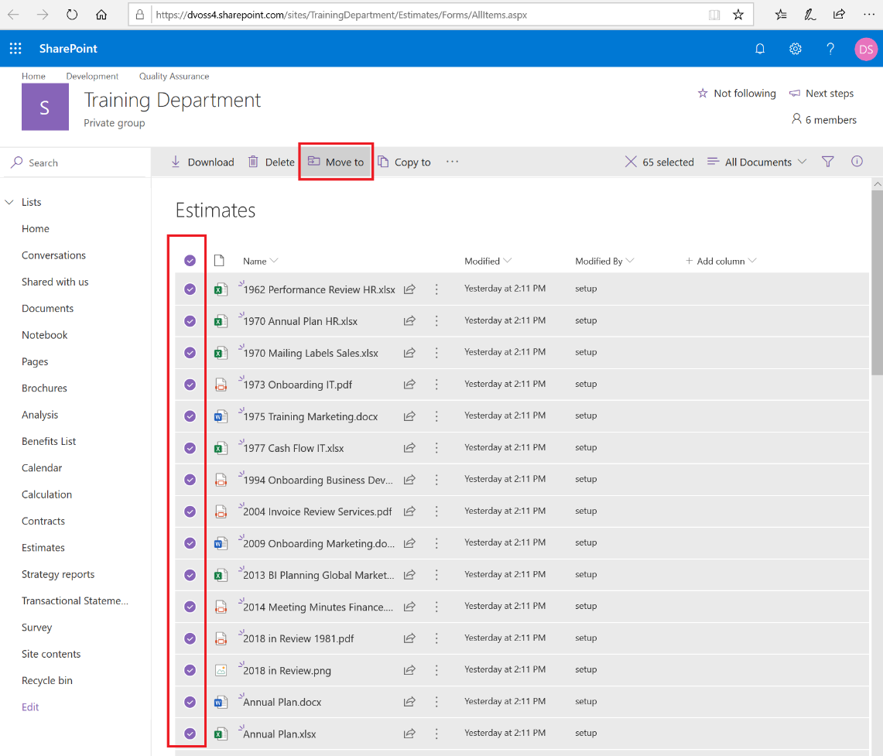

1. In the **Places** screen, select the site if it appears in the list, or click **Browse** **sites** to locate the target site.
2. In the **Choose** **a** **destination** screen select the “**Documents**” library, then click on the “**General”** folder, then click **Move** **here**.

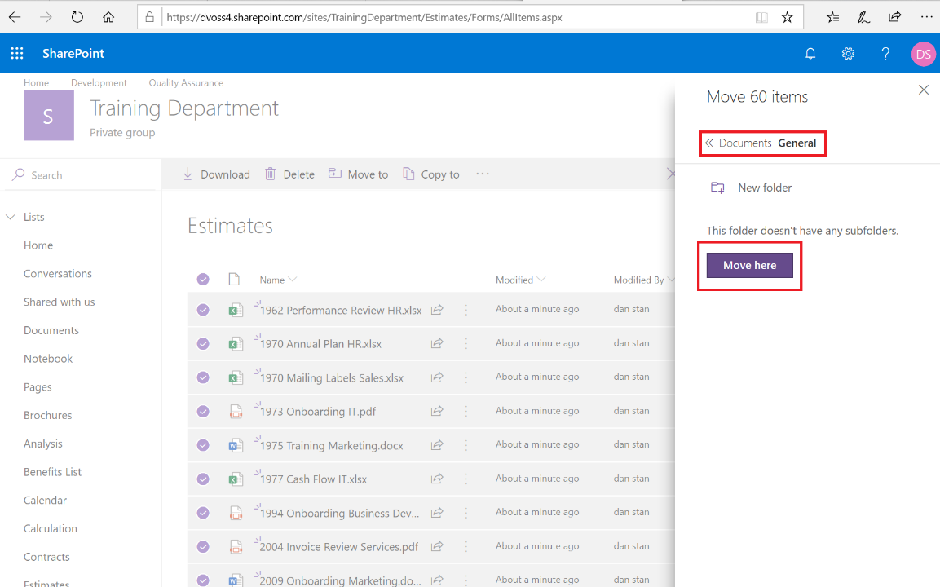

1. Navigate to Teams Apps and click on the team’s general channel. Click on the **Files** tab and confirm you see the files moved from the previous steps:

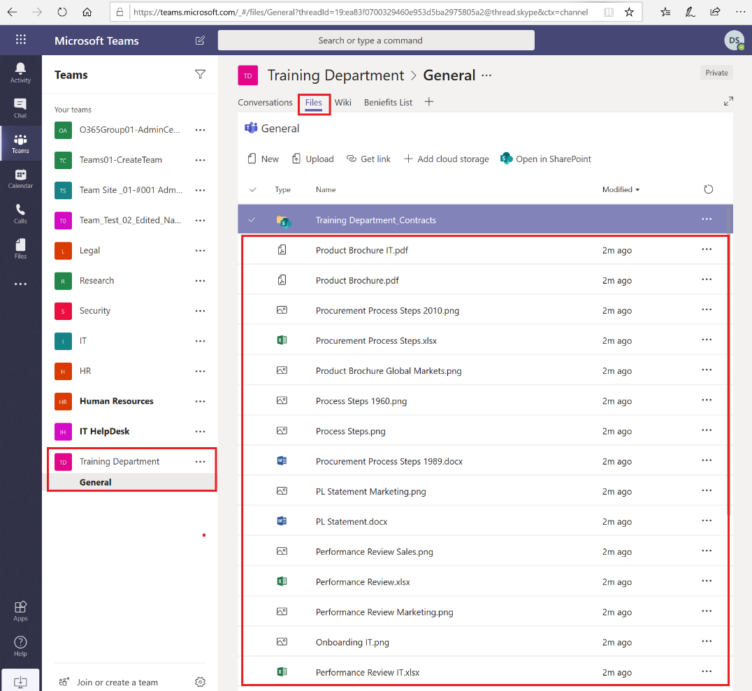

### Create a new team from a SharePoint Online site

Choose one of the SharePoint Online sites migrated in scenario ***4.1 Migrate SharePoint Server content to SharePoint Online***. Create a team from the SharePoint Online site. Surface the migrated content in the SharePoint Online site in Teams.

#### Connect the modern SharePoint Online to a Microsoft 365 Group

Before you can create a team from a modern SharePoint Online site, the site must be connected to a new Microsoft 365 group first.

1. Open a browser and navigate to one of the new SharePoint Online sites created in scenario 4.1.
2. Click on the SharePoint **Settings** gear icon then click **Connect to new Microsoft 365 Group**.

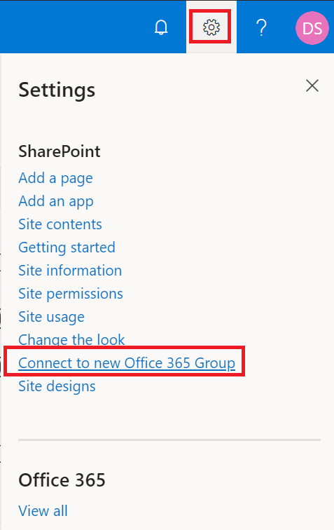

1. In the **Associate this team site to a new Microsoft 365 Group** screen review the steps that will be performed, then click **Let’s get started**.

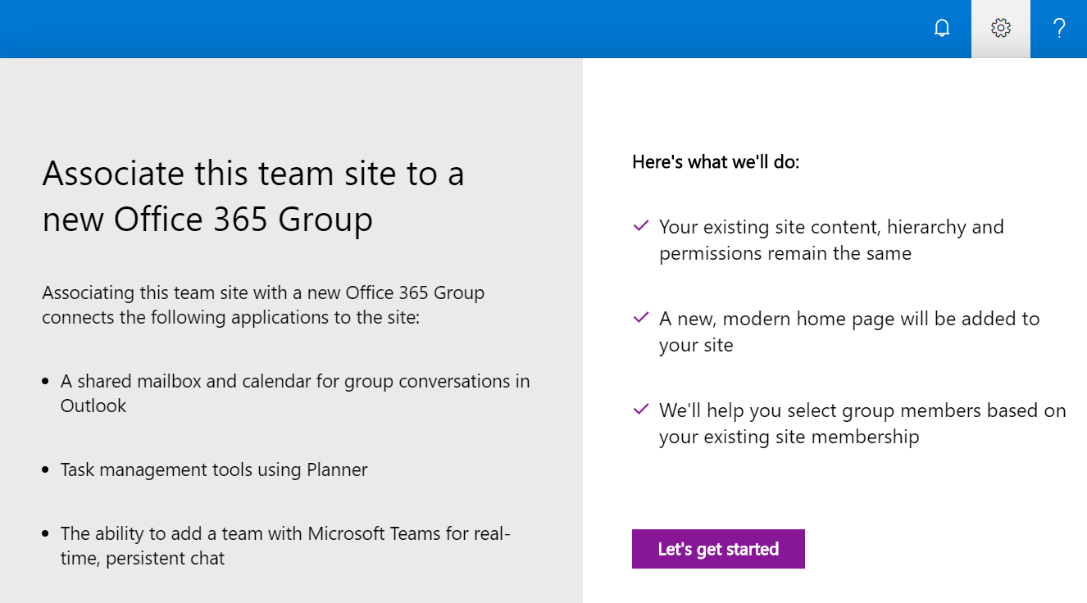

1. In the **Tell us about your new Microsoft 365 group** screen, in the **Group name** dialog box leave the default name (or enter a different name) for the Group. Ensure the **Group email address** alias is available. Leave the **Site description** default. In the **Privacy settings** dropdown ensure **Private – Only members can access this site** is selected. Click **Connect group**.

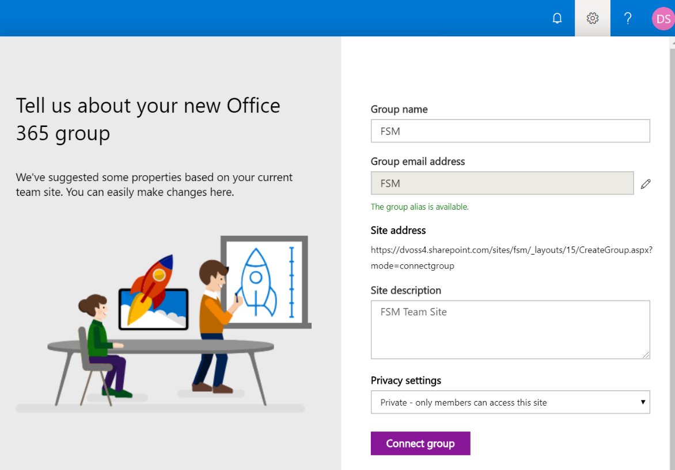

1. In the **Add and assign people** screen, in the **Add additional owners** and **Add members** boxes leave the default permissions or add additional users. Click **Finish**.

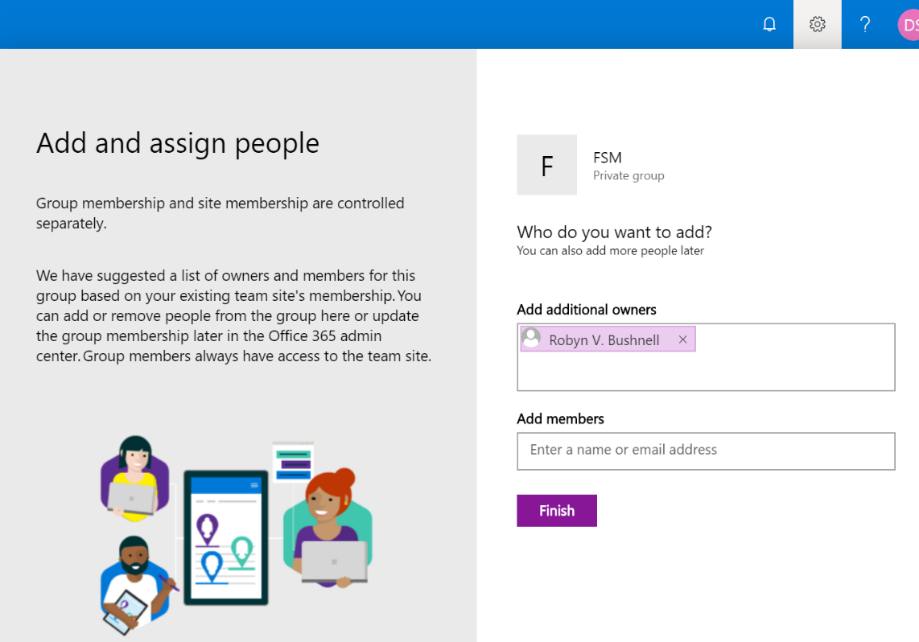

#### Create a Team from the new Microsoft 365 Group connected SharePoint site

Now that the SharePoint Online site has been connected to a Microsoft 365 Group it can now be used to create a new Team.

1. Navigate to the home page of the new Microsoft 365 Group connected SharePoint site. If you are already on the page, refresh the browser session so the home page loads again.
2. In the bottom left corner of the site you will see a **Microsoft Teams** logo with the following message: **Communicate with your colleagues in real time by creating a Team for your Microsoft 365 Group**. Below the text click the link **Create a Team**.

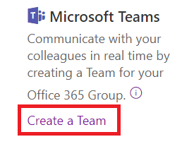

1. After clicking Create a Team a progress bar will appear. After the task is complete, click the link **Success! Click here to go to your team**.



1. In the Microsoft Teams splash screen click **Join on the web instead**. Alternatively, if you want to download the Windows App, or launch the Teams App (if already installed) select those choices. The steps to surface content are the same regardless if using the Teams App or the Teams App in the browser.

#### Surface the content in Teams

Using the Teams App interface in the browser (or the Windows App) surface content in the new team you created in the previous step by adding Tabs, adding cloud storage and/or using the SharePoint Move feature. For reference the steps are the same from scenario **4.2.4 Surface the content in teams, using Tabs, Cloud Storage or Move feature.**